WEBSITE ITOOLS

User Guide

|  |  |  |
| --- | --- | --- |
|  | ***Last updated by:*** | *Nguyen Ngoc Tan Thuong* |
|  | ***Effective date:*** | Aug 14, 2018 |
|  | ***Version:*** | *1.0* |

# Document Control

|  |  |  |  |  |  |
| --- | --- | --- | --- | --- | --- |
| Version | Change description | Changed by | Date | Approved by | Date |
| 1.0 |  | Thuong Nguyen | 16-Aug-2018 | Thuong Nguyen | 16-Aug-2018 |
|  |  |  |  |  |  |
|  |  |  |  |  |  |
|  |  |  |  |  |  |
|  |  |  |  |  |  |

Table of Contents

**1.** **Login screen:** 4

**a.** **Login function :** 4

**b.** **Reset function :** 4

**c.** **Forgot password function :** 4

**2.** **Forgot password screen:** 5

**3.** **Change password screen:** 7

**4.** **Machine List screen (Main screen):** 8

**a.** **Add new machine:** 8

**b.** **View Machine detail:** 9

**5.** **Company Management Screen:** 11

**a.** **Create new Company:** 11

**b.** **Edit a company:** 11

**6.** **Tool Management screen:** 13

**a.** **Create new tool:** 13

**b.** **Edit tool:** 14

**c.** **View tool screen:** 15

**7.** **User management screen:** 16

**a.** **Create new user:** 16

**b.** **Edit user screen:** 17

**c.** **Add role screen:** 18

**8.** **Working Transaction screen:** 21

- **Condition :** 21

**9.** **User credentials:** 26

1. **Login screen:**

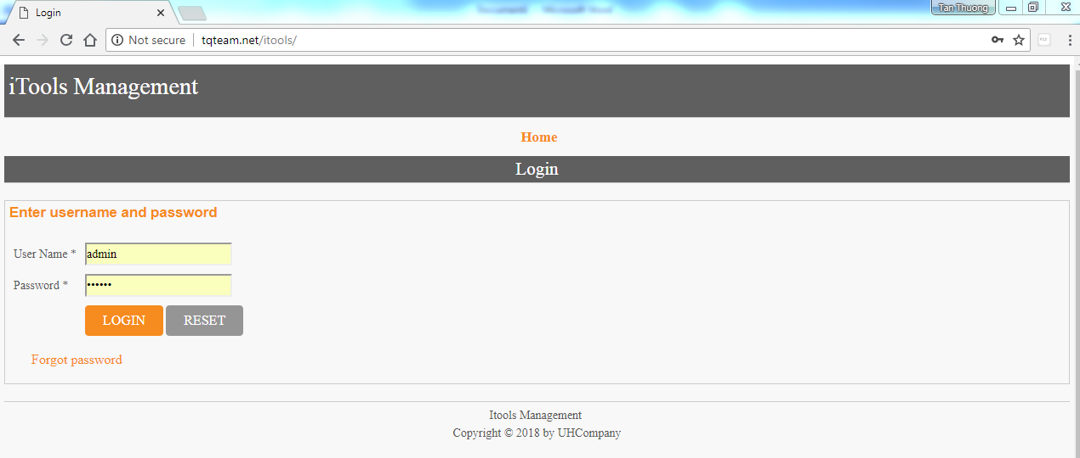

* 1. **Login function :**
* Input username
* Input password
* Click on Login button and go to Machine Screen.
  1. **Reset function :**
* Click on reset button and clear all data in username and password.
  1. **Forgot password function :**
* Click on Forgot password for receive a new password for selected user. ( view Forgot Password Screen)

1. **Forgot password screen:**

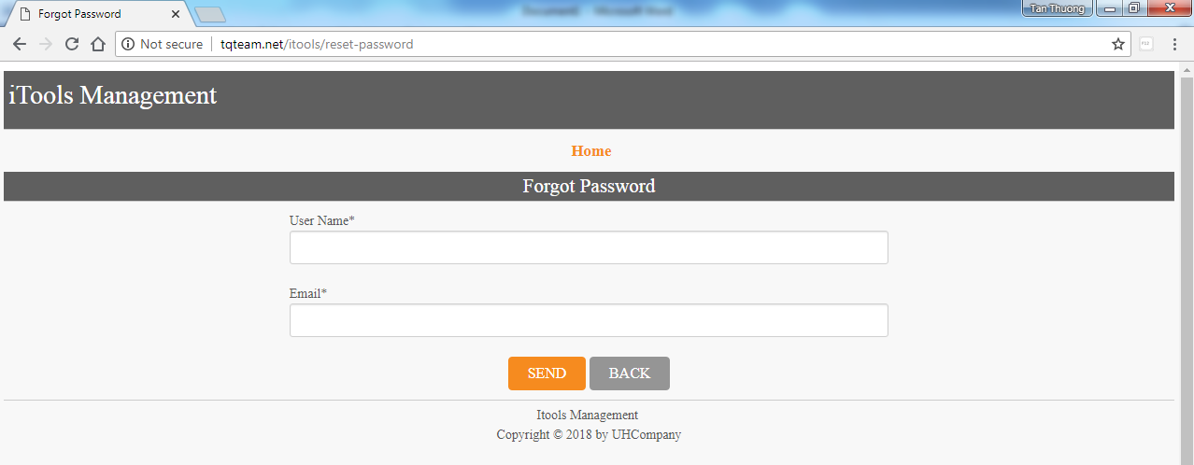

* Input username
* Input email address of this user.
* Click on Send button and a new password will be sent to email address of input user.

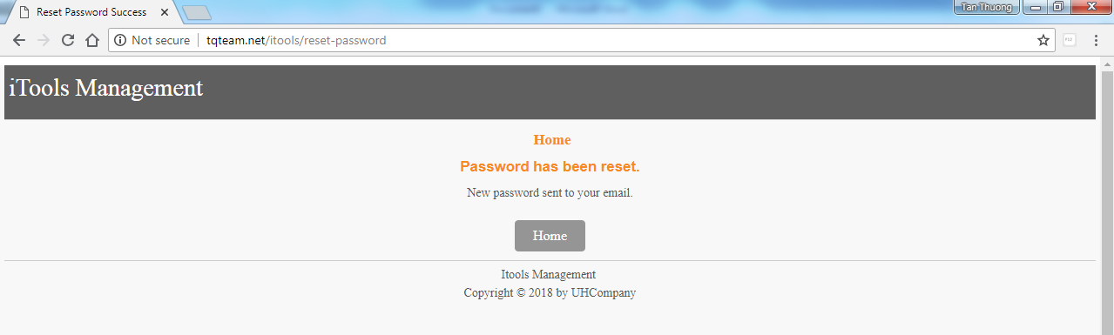

* If input email address of input user is not valid, error message will be display.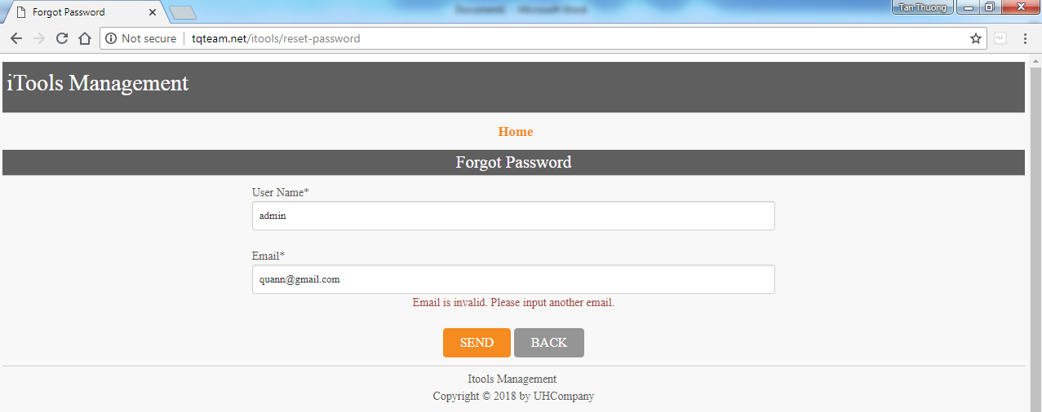
* If input a user is not exist, error message will be display. 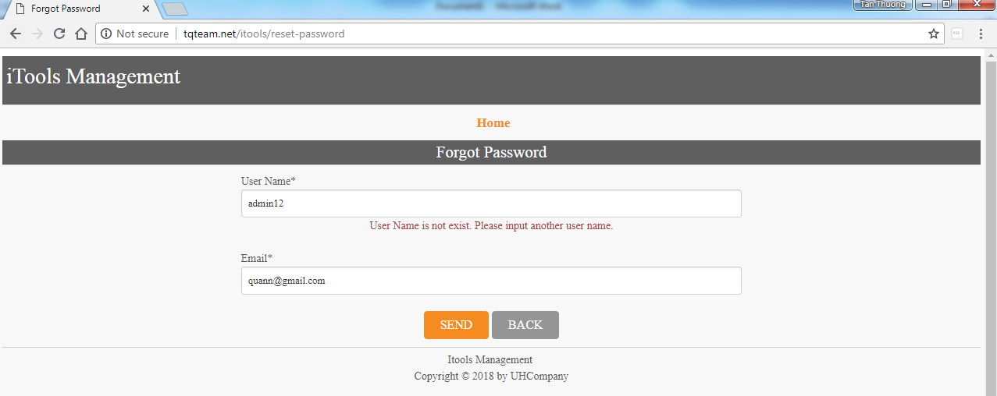
* Click Back and return login screen.

1. **Change password screen:**

* After reset password, in the first time login, user will be forwarded to this screen.
* User can use this function by clicking on this link



* Screen displays as below:

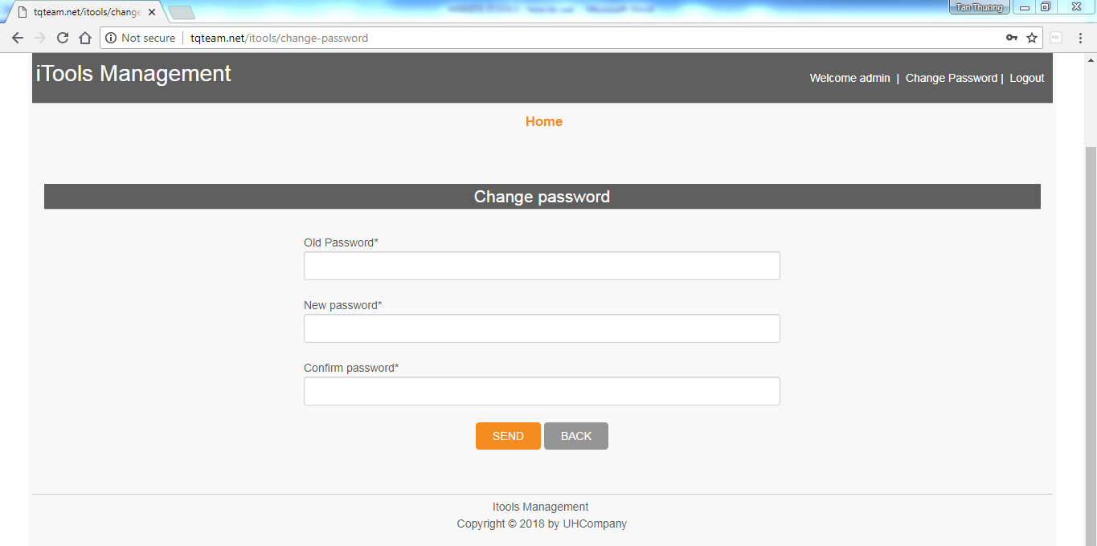

* User must input current password (or password which sent to user’s email) and input new password.
* Confirm password must match with new password.
* Click Send button and finish change password.

1. **Machine List screen (Main screen):**

* After login, user will be forwarded to this screen.

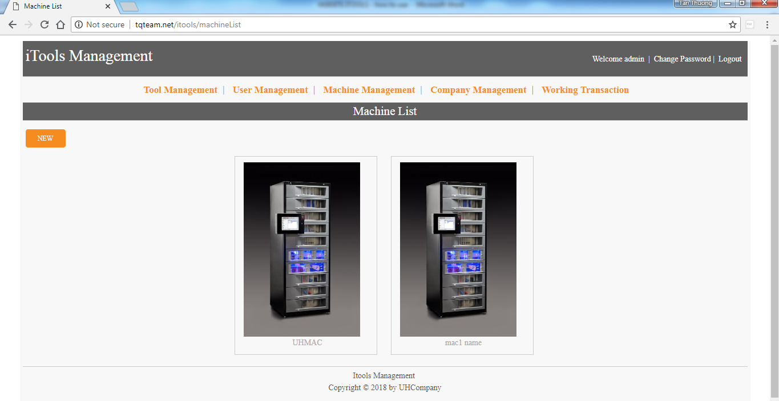

* Admin can view all machine, sub-admin just see machine of his company.
  1. **Add new machine:**
* Click on New button for creating new machine.

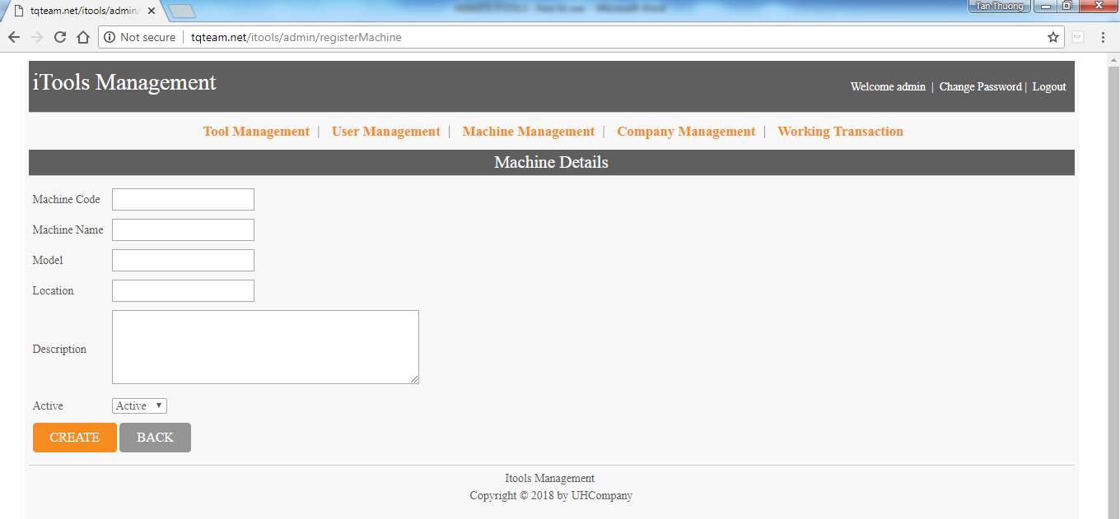

* Input Machine Code and Machine Name. This field cannot null, must input text.

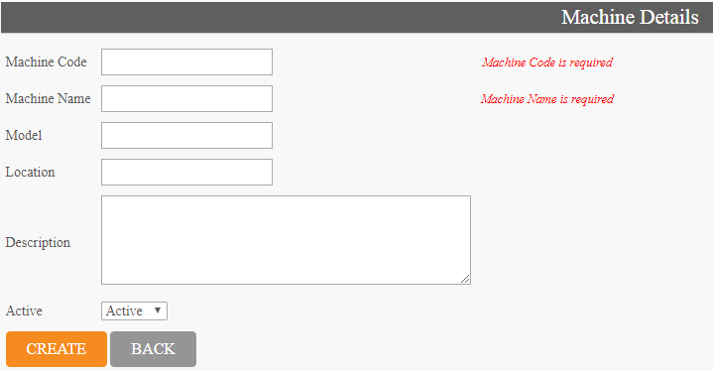

* Input Model, Location, Description. This field is optional, not required to input.
* Choose Active or Disable, default is Active.
* Click on Create to finish creating new Machine or click Back to return Machine List.
  1. **View Machine detail:**
* Click on a machine in list and go to Machine detail screen.

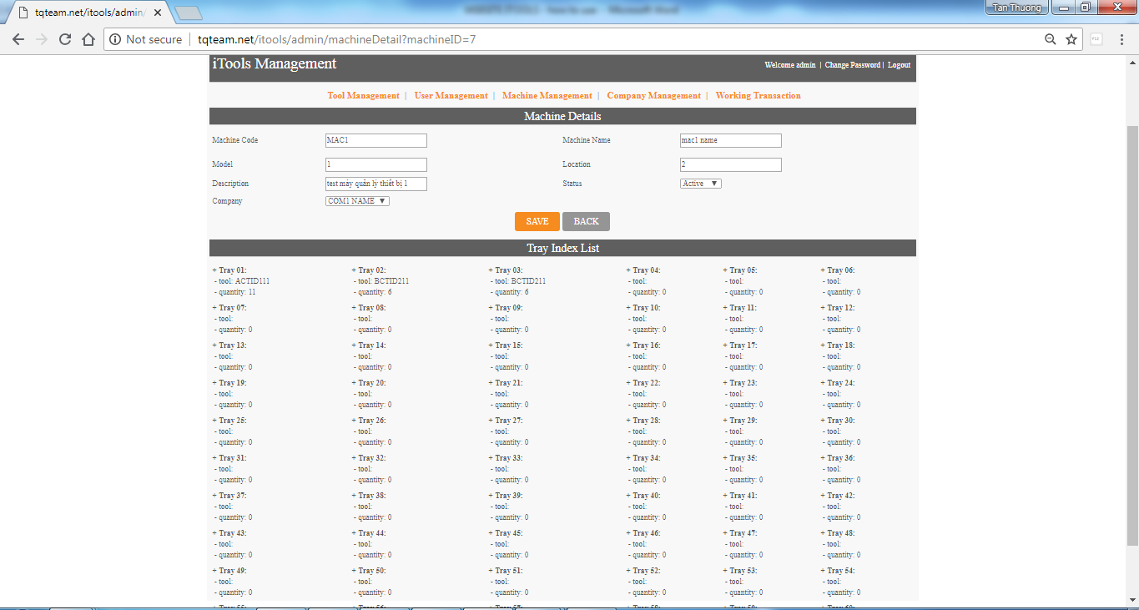

* This screen has 2 part, above is detail of machine, below is Tray Index list.
* Detail of Machine :

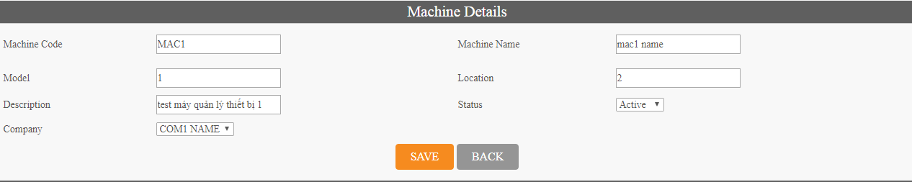

* + Admin, sub-admin, accounting can edit machine code, machine name, model, location and Description
  + Admin can change company and status (active, disable). Sub-admin and accouting just view company and status.

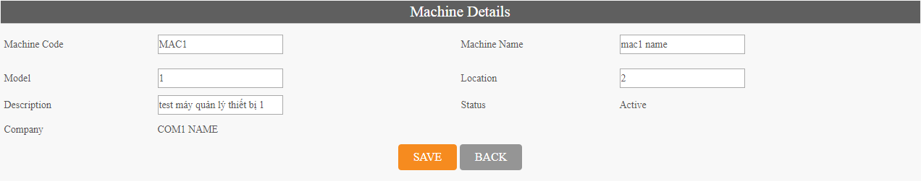

* Tray Index List : displays info of 60 trays in current machine (tool code in tray, quantity of tool)

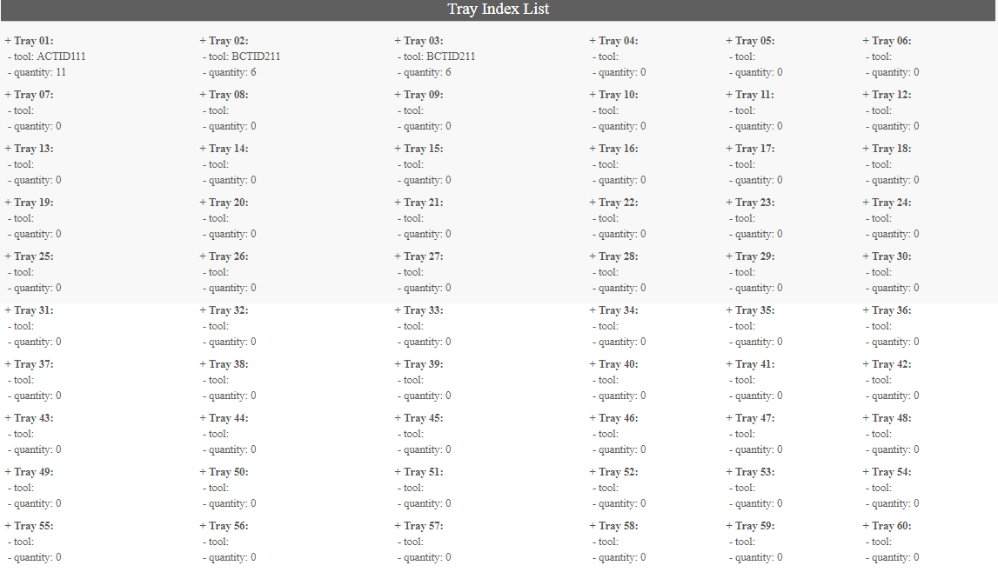

1. **Company Management Screen:**

* Click on Company Management in menu and go to this screen
* Just only admin can user this function, sub-admin and accounting cannot see this screen.

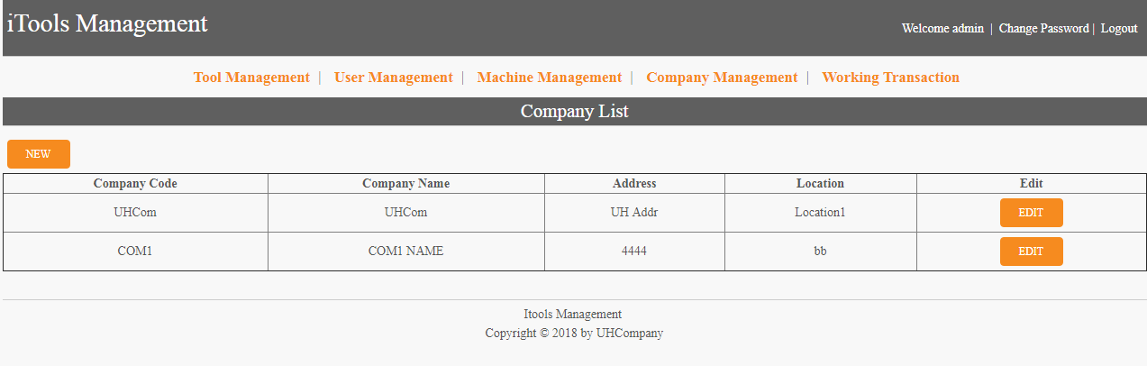

* 1. **Create new Company:**
* Click on new button in list screen and go to Create company screen.

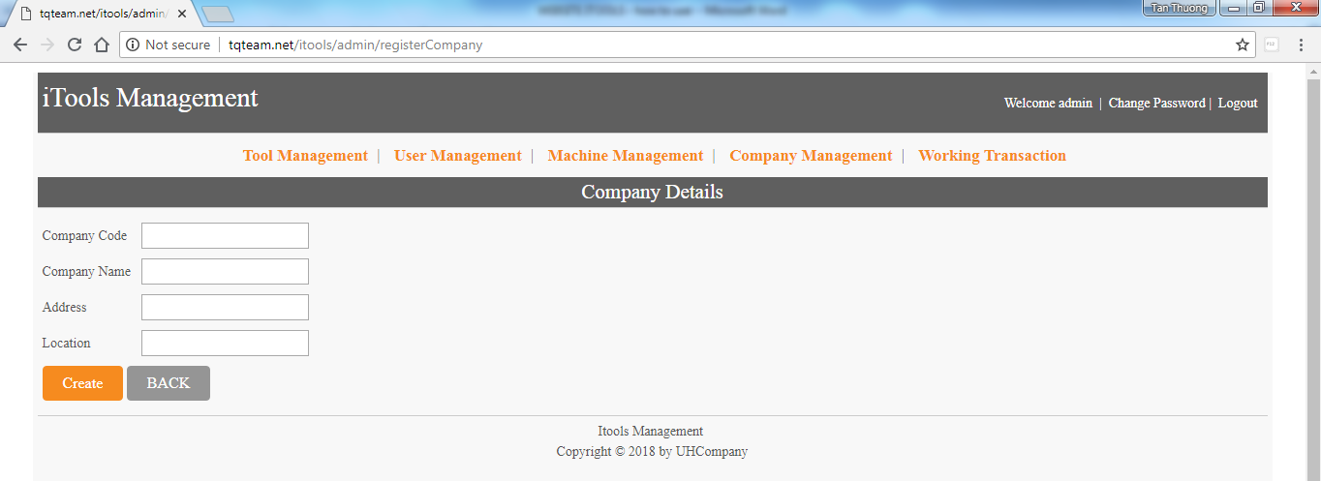

* Company Code and Company Name must be input.
* Address and Location is optional.

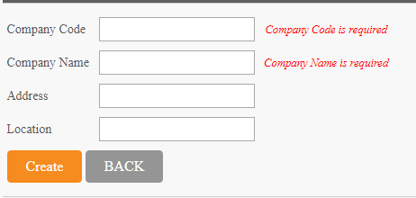

* Click on Create button and create new company.
  1. **Edit a company:**
* Click on edit button behind a company and go to edit screen.

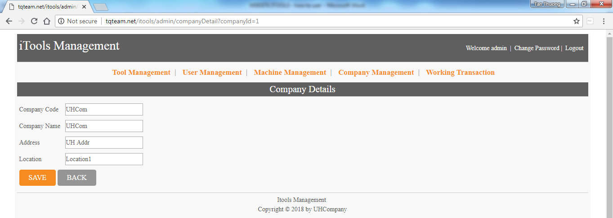

* This screen is the same screen with create company function.

1. **Tool Management screen:**

* User click on Tool Management link in menu and go to this screen

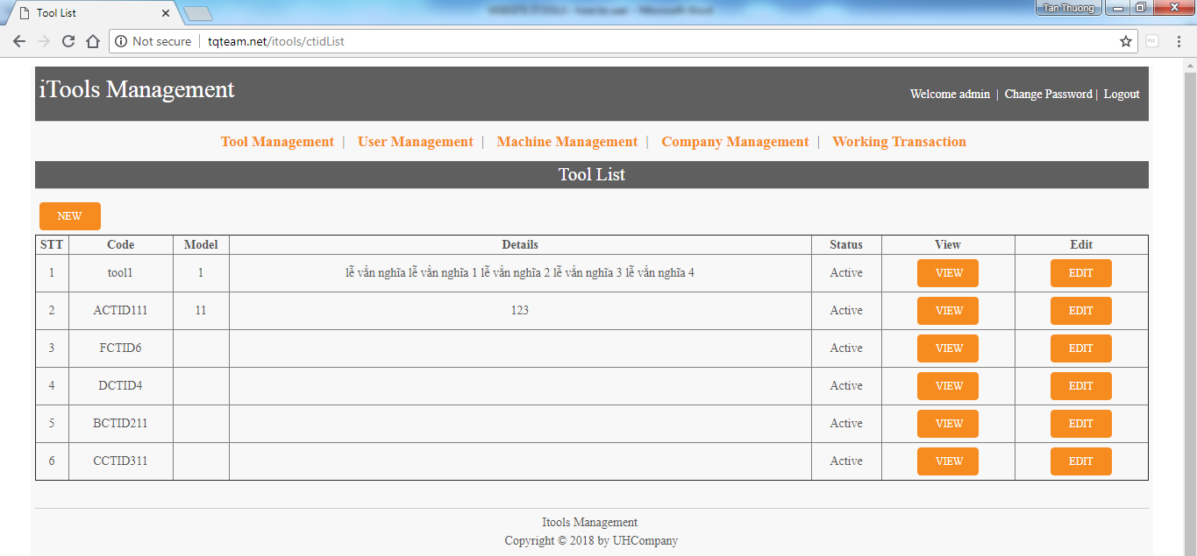

* Sub-admin just only see view button and cannot see edit button.

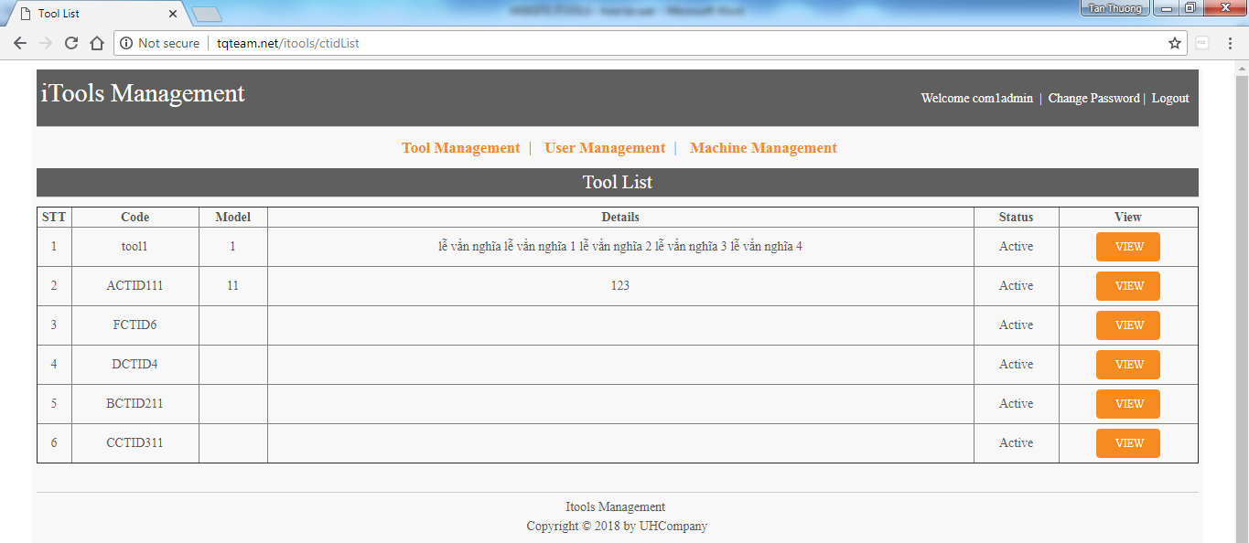

* 1. **Create new tool:**
* Click on New button and go to create tool screen.

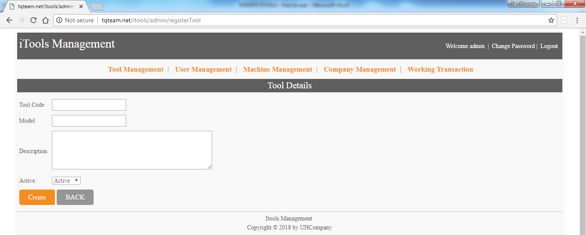

* Tool code is required to input.
* Model and Description is optional.
* Can choose status active or disable.

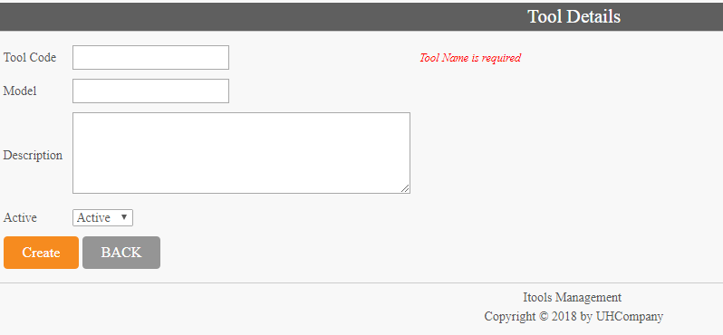

* 1. **Edit tool:**
* Just only admin can use this function.
* Click on edit button behind tool.

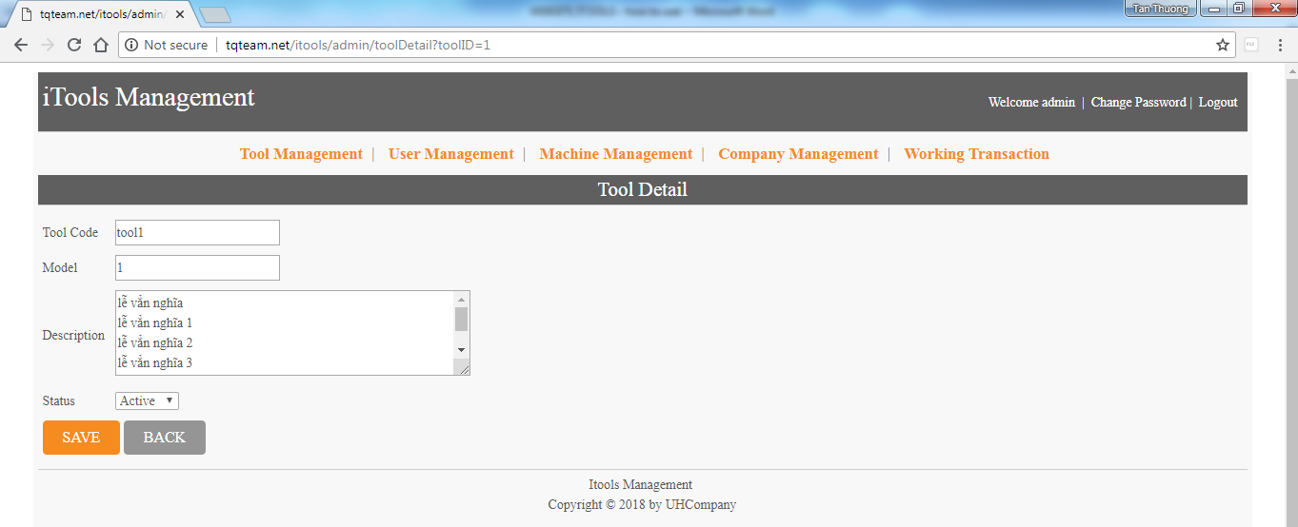

* Click on Save button for saving change or click on back and go to Tool List screen.
  1. **View tool screen:**
* Sub-admin just only view tool and cannot edit.

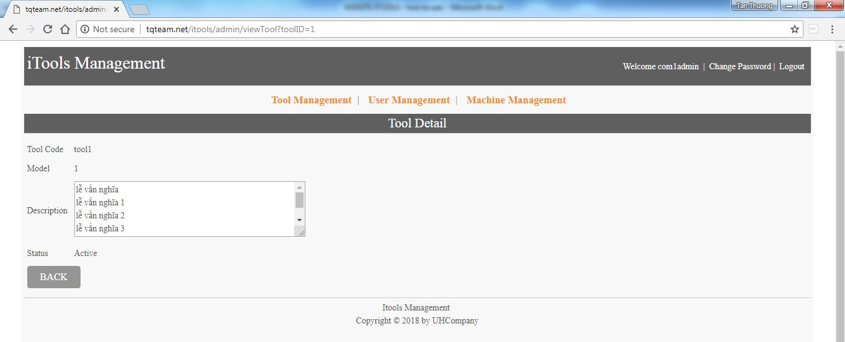

1. **User management screen:**

* Click on User Management in menu and go to this screen.
* Just only admin and sub-admin use this function.

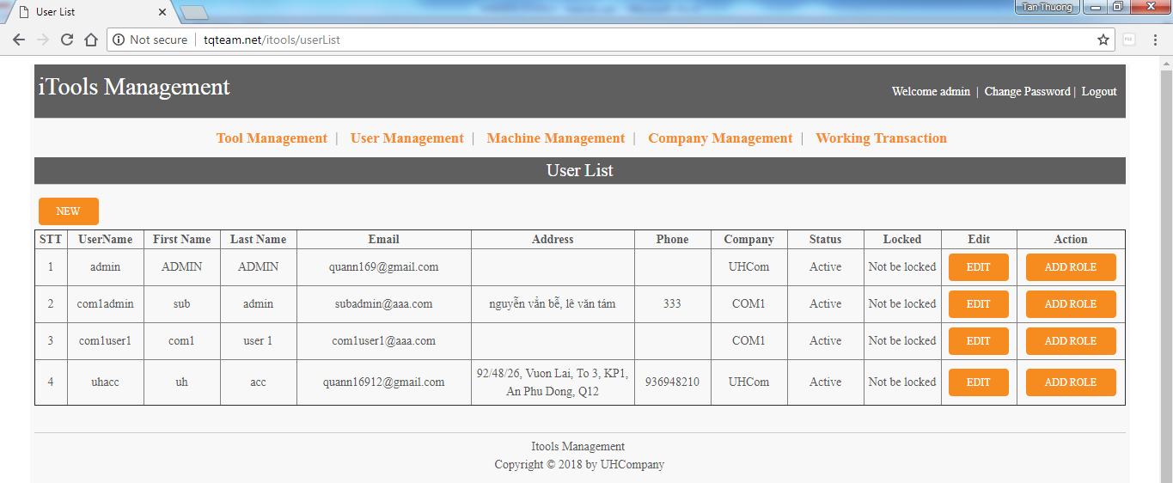

* Sub-admin just only see user of his company.

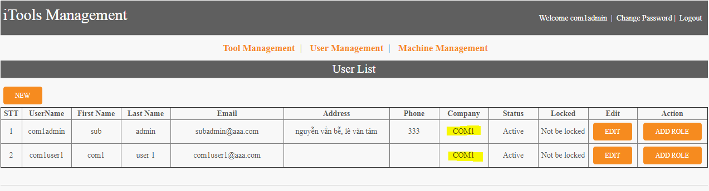

* 1. **Create new user:**
* Click on new button and go to this screen.

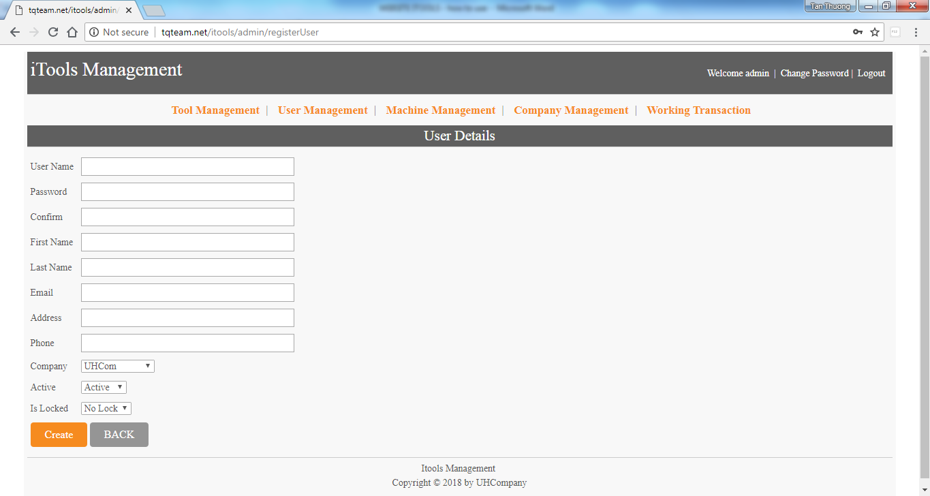

* Sub-admin just add new user for his company

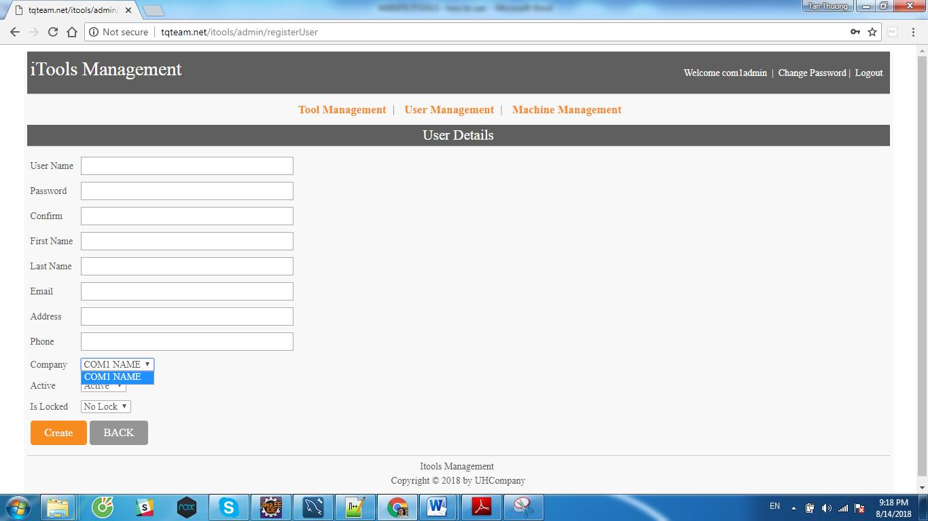

* User name, password, confirm password, first name, last name, Email is required and cannot null.
* Email must input with valid format, ex : [aaa@xxx.com](mailto:aaa@xxx.com),...
* Address and Phone is optional.
* Admin can choose company for user.
* Status of user is Active or Disable, default is active.
* Is Locked is No Lock or Locked, default is No Lock.
* Click Create button for finishing create user or click back and return user list screen.
  1. **Edit user screen:**
* Click on Edit button behind user and edit user

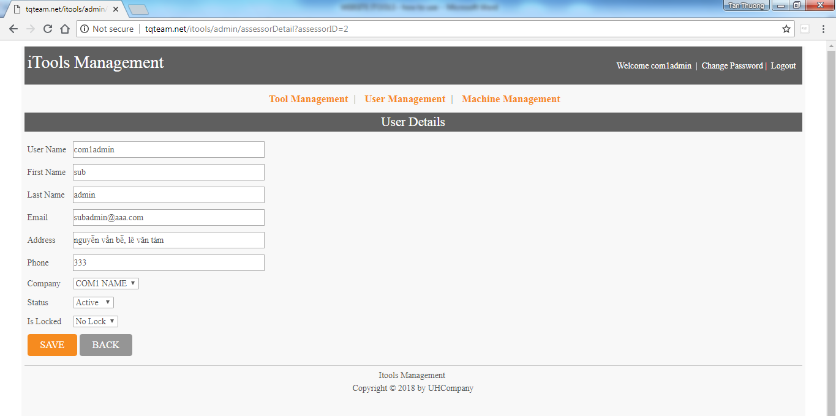

* 1. **Add role screen:**
* Click on Add Role button behind user and go to this screen.

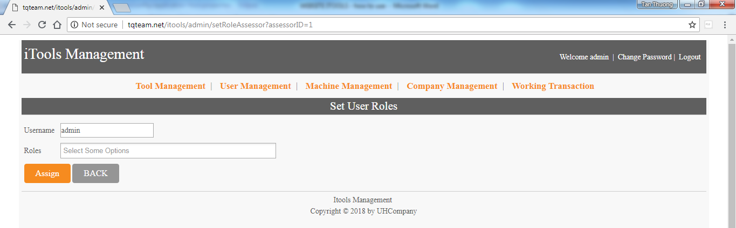

* Sub-admin just only set role sub-admin, accounting, Employee and Other for user.

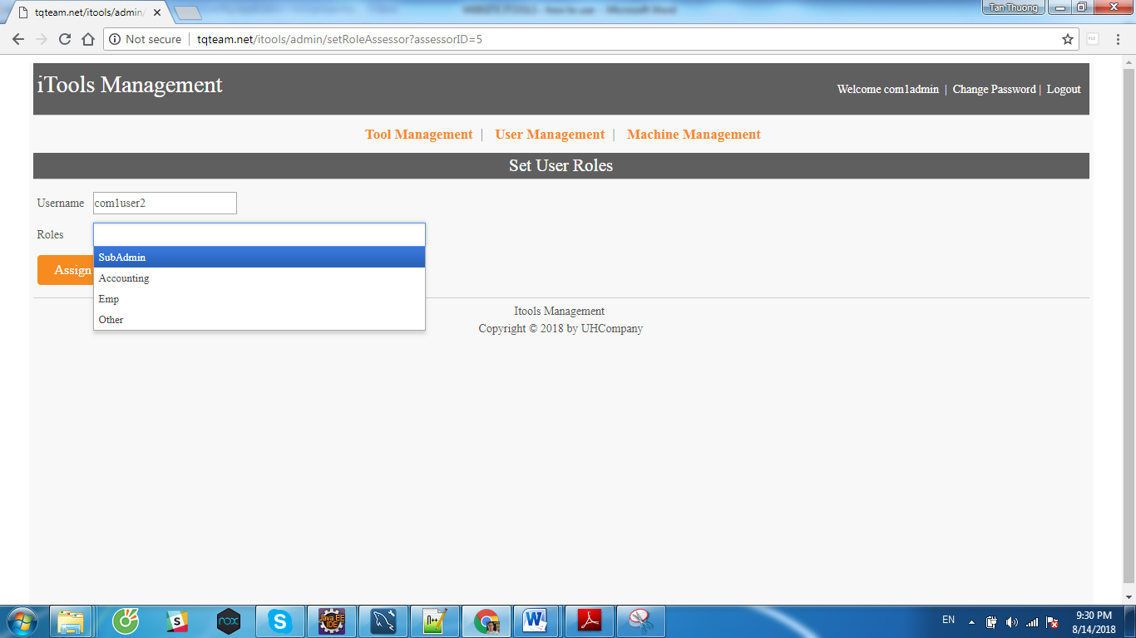

* Admin can set role admin, sub-admin, accounting, Employee and Other for user.

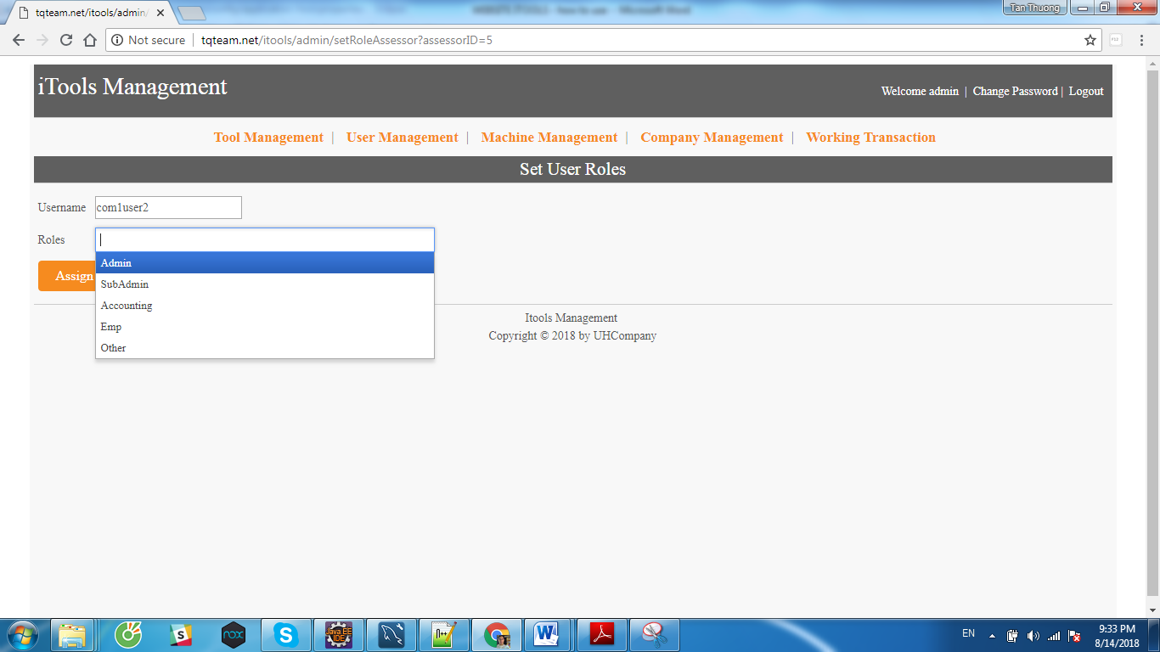

* Roles list just only show roles which this user have not. If a role set for this user, that role will not show in this list.

Ex : Uhacc have accounting role, so cannot set accounting role again.

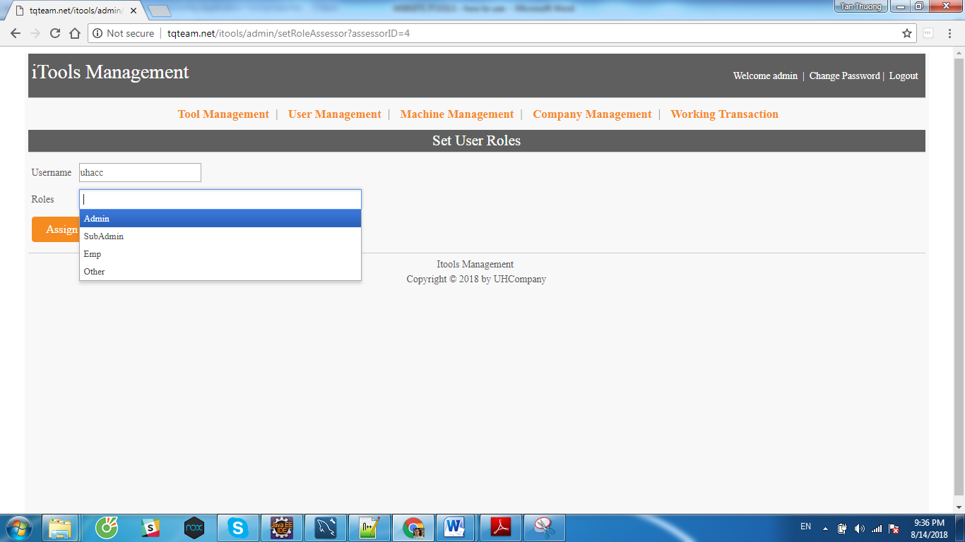

* Choose a role and click on Assign to set role or click on Back button and go to User List.

1. **Working Transaction screen:**

* Click on Working Transaction in menu and go to this screen.

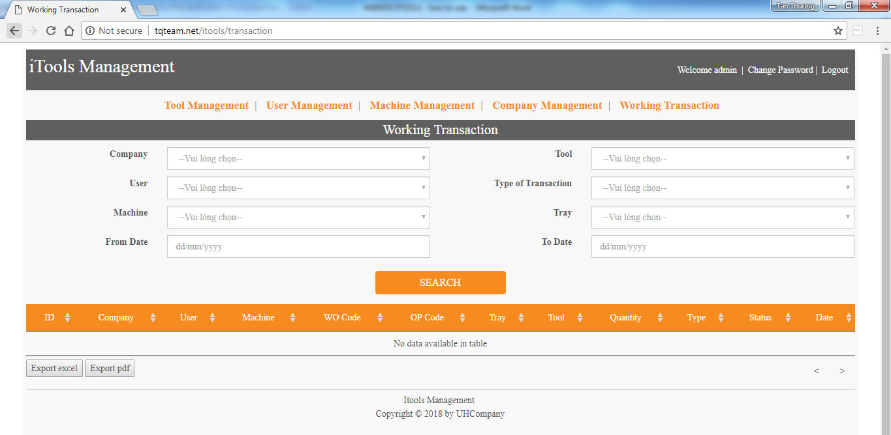

* There are 8 condition value for searching working transaction infomations.
* Default without any condition, will display all working transaction. Click on Search button for display.

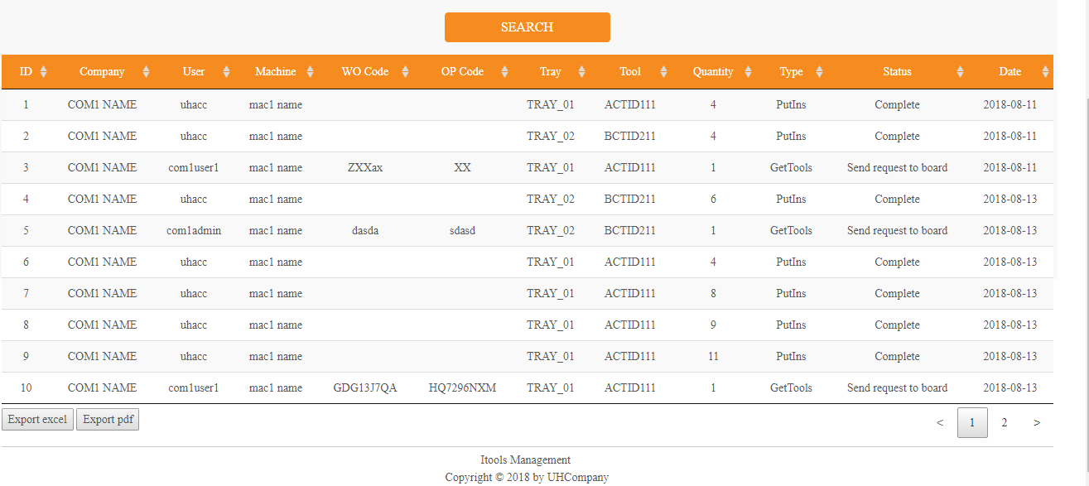

* Click on export excel or export pdf button for exporting to file (excel file or pdf file).
* **Condition :**
  + Company

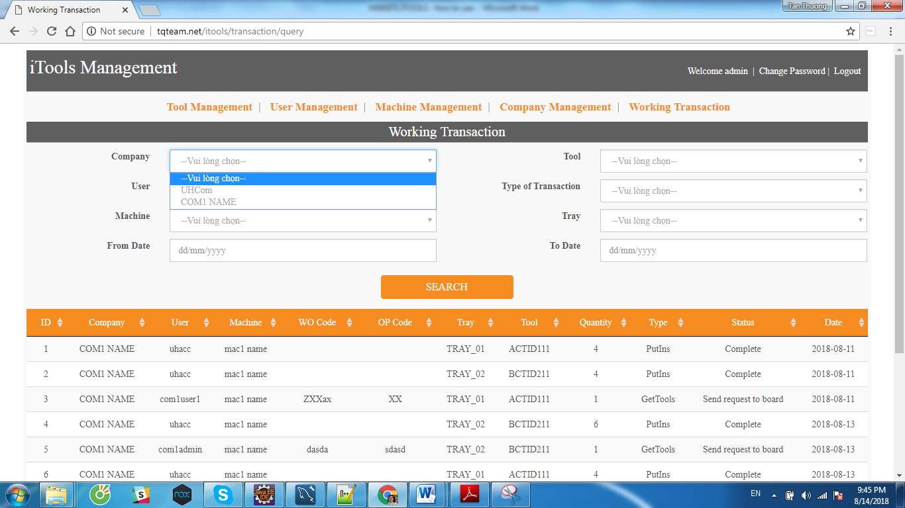

* + User

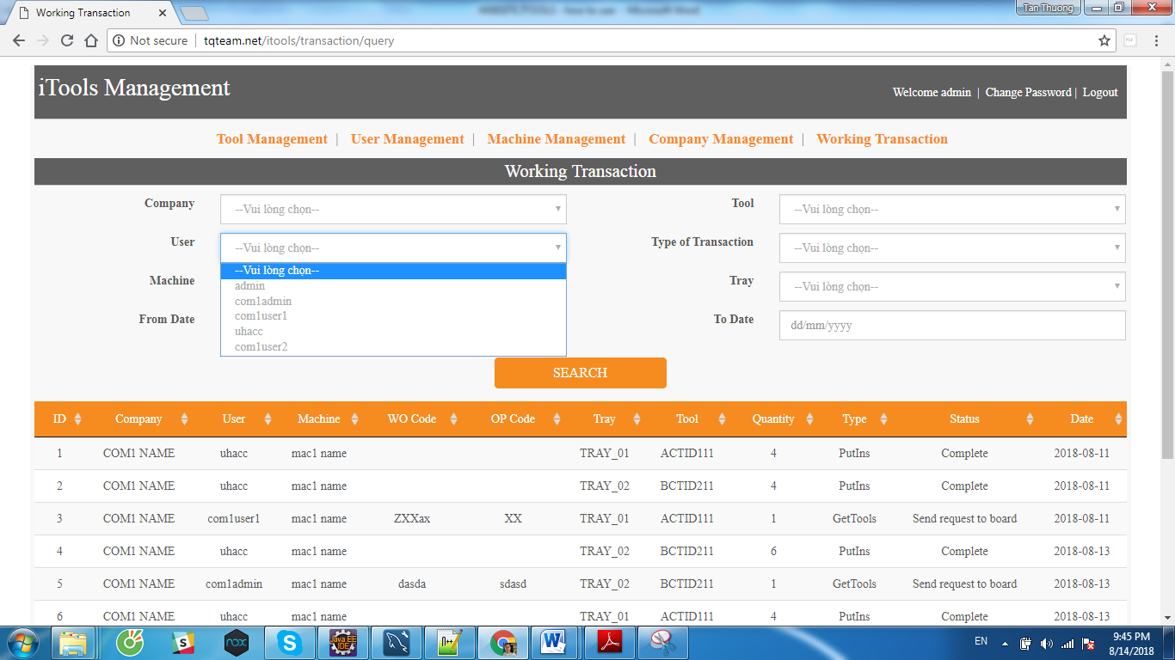

* + Machine

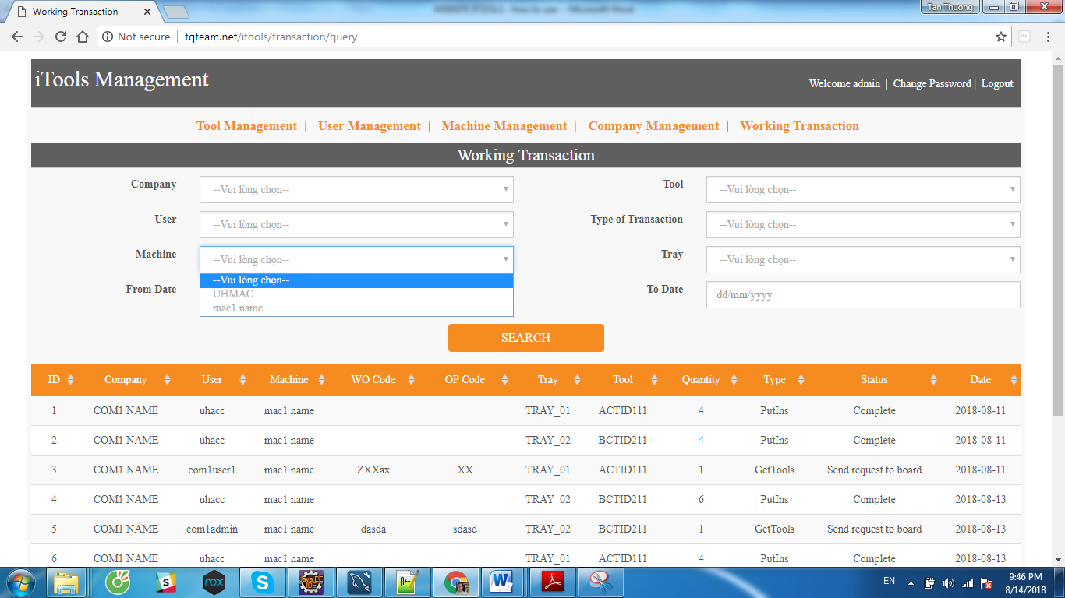

* + Tool

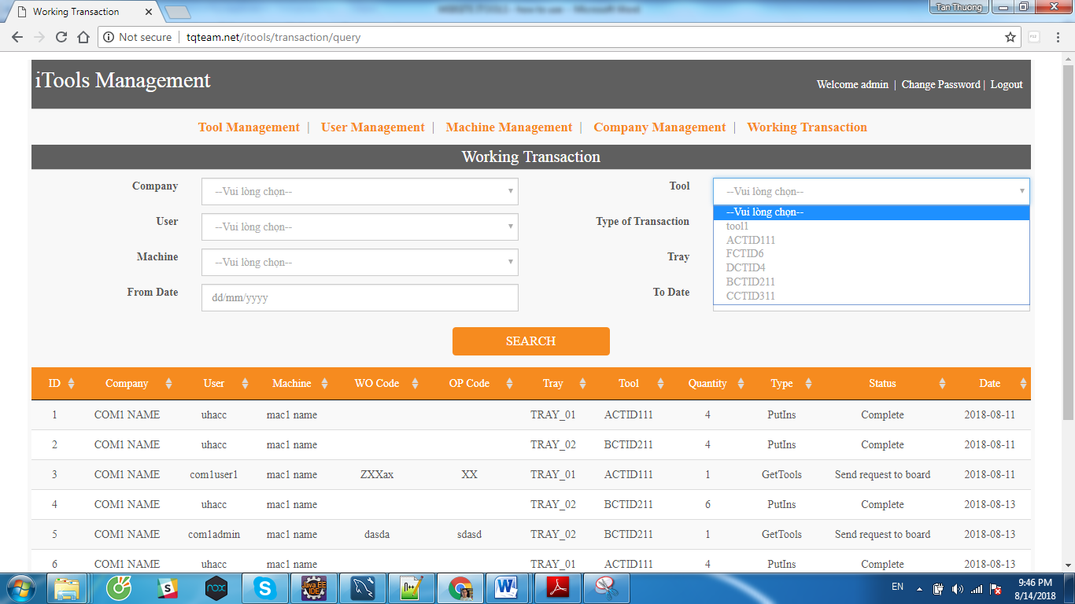

* + Type of transaction

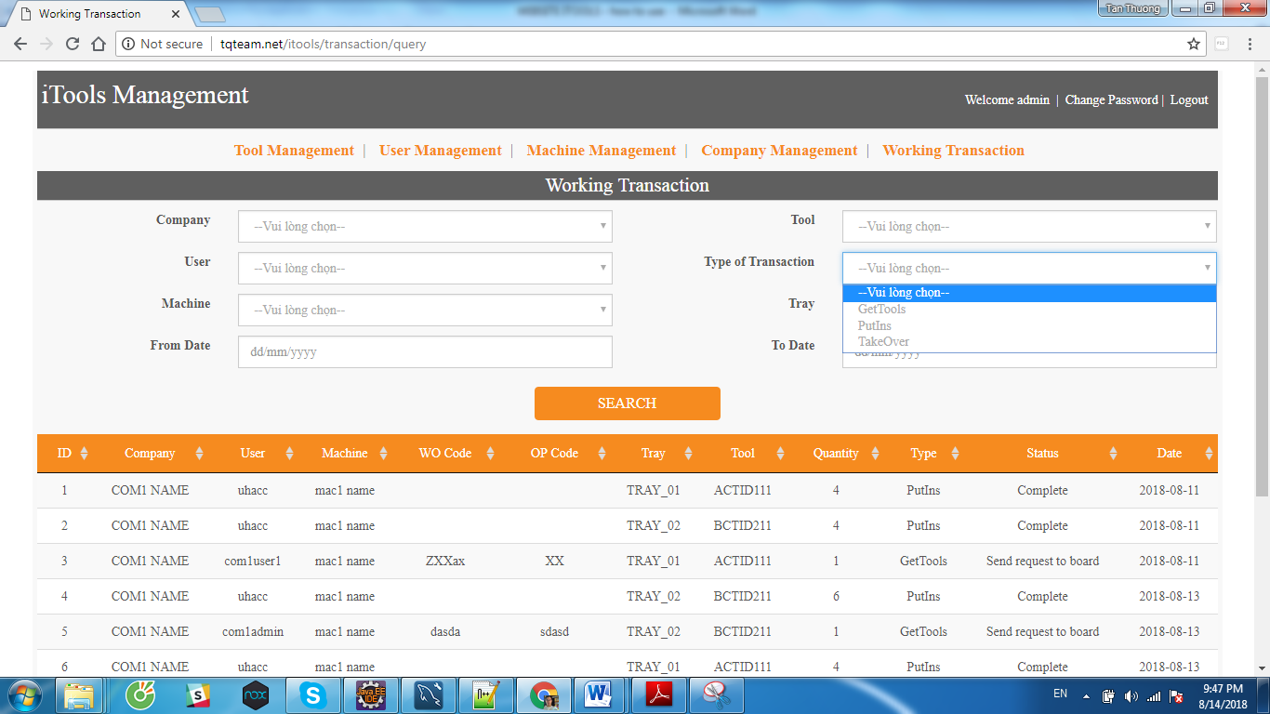

* + Tray

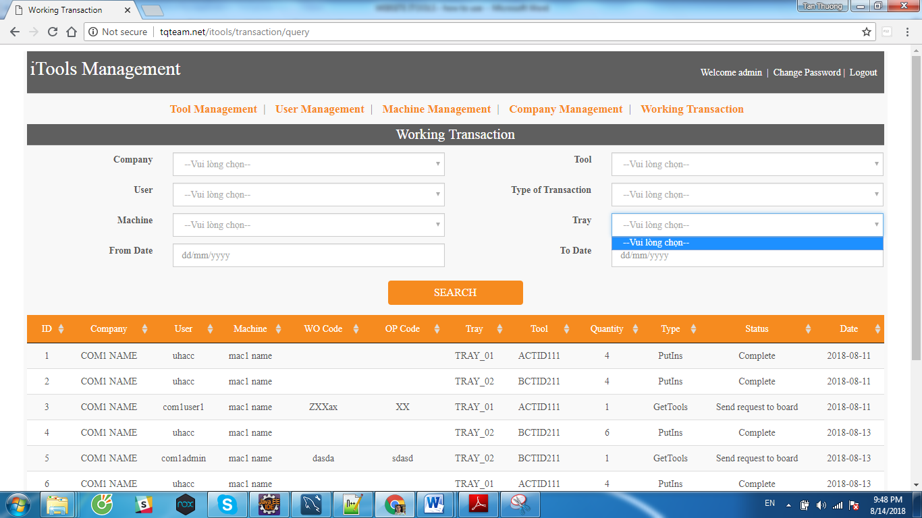

* + From date and To Date

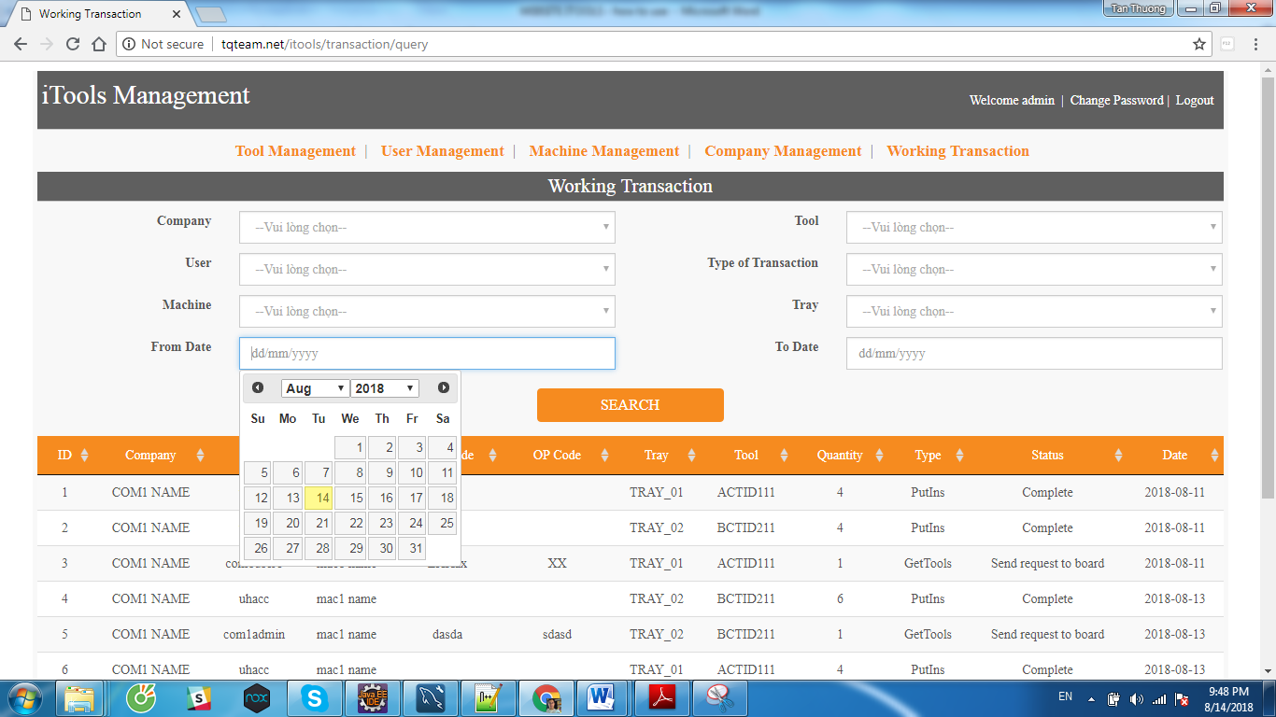

1. **User credentials:**

* There are 5 role in this website :
  + Admin
  + SubAdmin
  + Accounting
  + Emp (Employee)
  + Other
* Admin can view all screen and do all function
* Emp and Other user cannot use this website, just only Employee user can use App Machine.
* Sub-Admin can :
  + See 3 function User Management, Machine Management and Working Transaction

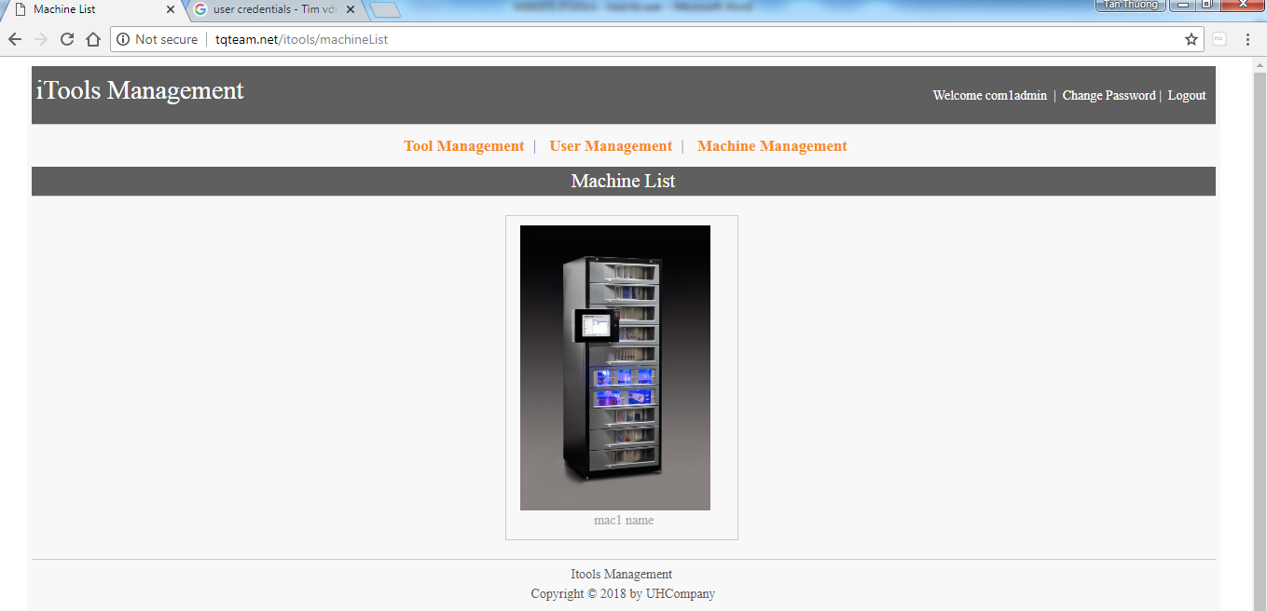

* + In Tool Management, just only view tool
  + In User Management, just only create and set role for his company.
  + In Machine Management, cannot add new machine and cannot change company, status of Machine.
* Accounting :
  + See 2 function Machine Management and Working Transaction

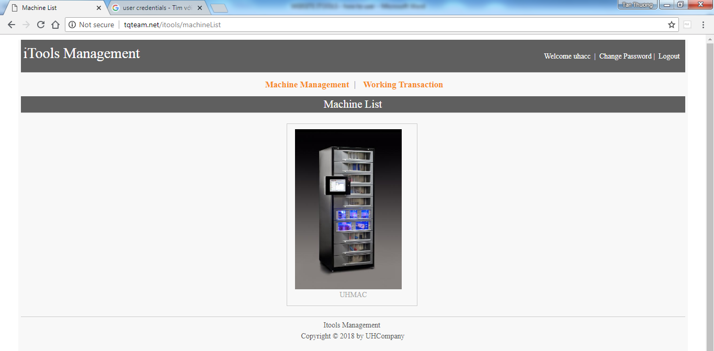

* + In Machine Management, cannot add new machine and cannot change company, status of Machine.



END USER GUIDE.